CURRICULUM VITAE
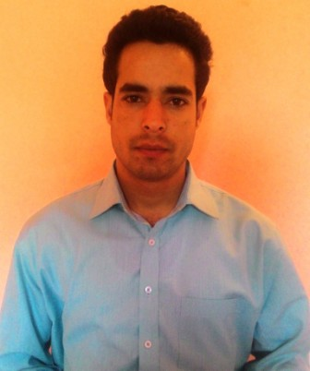  PERSONAL DETAILS  Name : Nazim Majeed  S/O : Ab. Majeed Bhat  D.O.B : 15/03/1992  Gender : Male  Marital Status : Unmarried  Languages : English, Urdu, Kashmiri  Email ID : nazimajeed1@gmail.com  Mobile No. : 9742830307, 8491999337  8715805296  Address : Brienty Batpora (192210)  District : Anantnag  State : Jammu & Kashmir  Present Address: Avalahalli Bangluru  Hobbies: Volleyball, Interaction with strange people. | CAREER OBJECTIVE
 | To obtain a challenging position in a high quality engineering environment where my resourceful knowledge, ability and academic skills will add value to organizational operations.
 | ACADEMIC DETAILS
 | Course | Board/ University | Marks obtained | Percentage
 | B.E MECHANICAL | UNIVERSITY OF KASHMIR | I sem- 605/1000  II sem- 612/1000  III sem- 596/1000  IV sem- 643/1000  V sem- 746/1000  VI sem- 639/1000  VII sem- 689/1000  VIII sem-812/1200  Total - 5342/8200 | 60.5%  61.2%  59.6%  64.3%  74.6%  63.9%  68.9%  67.66%  65.14%
 | HSSE PART II  (12th) | JKBOSE | 445/750 | 59.3%
 | SSE  (10th) | JKBOSE | 356/500 | 71.2%
DECLARATION | SEMINAR DELIVERED ON
I hereby declare that the information given is true in the best belief of my knowledge  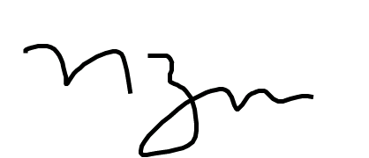  NAZIM MAJEED | Hexapod Robot
 | FINAL YEAR PROJECT
 | Design and Fabrication of Solar Grass Cutter
 | INDUSTRIAL EXPOSURE
Industrial Visit at : Hydroelectric Power Project Kangan
Ganderbal
: Swaraj Mazda Limited Chandigarh
In plant Training at : Mechanical Division Anantnag
: Peaks Auto Private Limited Anantnag
 | AREAS OF INTEREST
 | Production/Manufacturing, Inspection, Quality Control, Material Handling/Maintenance, Layout, Refrigeration and air conditioning, Power plant engineering, Fluid machinery.
 | STRENGTH
 | Quick learner, keen to learn, able to take responsibilities, ability to work well under pressure.

